Database Project Report Template
Due Date: 29/08/2026 - Week 3
Project ID & Title: #2: On-Demand Streaming Platform (Mini-Netflix)
A. Project Identity
- Team Name: No Man’s Land (NML)
- Team Members: Nhan Duy Tran (n25dece106@student.ptithcm.edu.vn), Lam Vo (n25dece055@student.ptithcm.edu.vn), Hung Minh To (n25dece092@student.ptithcm.edu.vn)
- Project Title: Mini-Netflix On-Demand Streaming Platform: Managing Complex Content Hierarchies and Tiered Membership Access through EER Modelling and Relational Normalization

B. Report structure

1. Introduction & Project Scope (Adapted from ISO/IEC/IEEE 29148)
1.1 Business & Product Overview
1.1.1. Product Definition
The proposed system is an On-Demand Streaming Platform (Mini-Netflix). The platform is a centralized multimedia delivery service designed to manage, categorize, and stream digital video content to end-users.
To accurately manage this catalog, the system categorizes "Content" into two distinct hierarchical types:
Movies: Standalone video files characterized by a single duration and video resolution.
TV Series Episodes: Serialized media units that belong to a broader TV Series container, requiring complex tracking of seasons and episode numbers.
1.1.2. Customer & User Definition
The platform differentiates between administrative staff and end-user viewing through a strict hierarchical structure:
Database Administrator (DBA): The chief administrator who oversees and manages the database and DBMS resources. The DBA is strictly a backend role responsible for authorizing access, monitoring database use, coordinating hardware/software acquisition, and securing overall system performance.
Account Owner (The Customer): The master billing account responsible for administrative duties and purchasing the service. This entity acts as the primary "Customer" who manages the subscription tier (Basic, Standard, or Premium), handles billing status, and has the authority to create or delete sub-profiles.
Profile (The Viewer): The actual end-user entity partitioned under a parent Account. Viewing sessions cannot happen at the Account level; they must be done through a Profile. Profiles are restricted to viewing content and managing personal preferences (e.g., language, avatars). Profiles can be designated as a "Kids Profile," which restricts their access to specific age-appropriate rating classifications.
1.1.3. Value Proposition
The core business objective is to deliver a seamless and engaging user experience through three primary value pillars:
Personalized Viewing Experiences: By isolating viewing metrics into distinct M:N associative entities (Watchlist, Watch History, and Profile Ratings), the platform ensures that mutations or actions on Profile A never affect the recommendations or history of Profile B.
Tiered Access Control: The platform incentivizes upgrades by enforcing role-based content access. A user's subscription tier dictates their maximum video quality, the number of allowed concurrent streams, and access to premium catalog items.
Structured Content Discovery: Utilizing a classification lookup catalog for genres and strict metadata tracking (release years, ratings), the platform allows users to efficiently navigate large libraries of both standalone movies and serialized TV shows.
1.2. System Objective
1.2.1. Scenario Overview & Technical Environment
The proposed database system models the core backend architecture of an On-Demand Streaming Platform (Mini-Netflix). In this Universe of Discourse (UoD), the system orchestrates subscriber billing, multi-user profile separation, tiered content catalogs, active streaming sessions, and personalized watch metrics.
1.1.2 Core Purpose & System Objectives
The primary objective is to implement a robust, scalable, and normalized relational database schema (up to BCNF) that achieves:
• EER Content Specialization: Structuring a Content superclass with specialized Movie and TV Episode subclasses, avoiding null-heavy schemas.
• Subscription Tier Access Control: Enforcing role-based content access and concurrent stream limits directly via relational constraints.
• Partitioned Profile Telemetry: Isolating viewing histories, ratings, and watchlists per profile using resolved M:N associative entities.
• Strict Referential Integrity:000 Enforcing composite keys, foreign keys, and ON DELETE CASCADE policies to eliminate orphaned records.
1.3 Business Rules & Constraints .
1.3.1 Operational Constraints & Semantic Integrity
1.3.1.1 Tier & Concurrency Rules
• BR-01 (Access Authorization): A Profile can only access Content where Content.required_tier_id <= Account.tier_id.
• BR-02 (Stream Caps): Active concurrent records in Active_Session for a given account_id cannot exceed Subscription_Tier.max_concurrent_streams.
1.3.1.2 Profile Isolation & Parental Control
• BR-03 (Data Isolation): Watch_History, ratings, and Watchlist rows are strictly scoped to profile_id. Mutations on Profile A must never affect Profile B.
• BR-04 (Kids Filter): If Profile.is_kids_profile = TRUE, queries must exclude Content with rating_classification IN ('R', 'TV-MA').
1.3.1.3 Cardinality & Referential Bounds
• BR-05 (Profile Threshold): Count of Profiles per account_id must satisfy 1 <= Count <= 5.
• BR-06 (Cascade Protocol): ON DELETE CASCADE applies from Account -> Profile -> (Watchlist, Watch_History, Active_Session).
1.3.1.4 User Interaction & Service Access
BR-07 (Service Prerequisite): An unregistered user cannot interact with the streaming catalog. The creation of a valid Account is required to interact with the database.
BR-08 (Profile Enforcement): An Account cannot directly initiate a streaming session or save content. All viewing telemetry (Active_Session), Watch_History, and Watchlist records must be strictly tied to a Profile entity.
BR-09 (Demo/Free Tier Limitation): If an Account is registered but has an inactive billing_status or belongs to a "Free/Guest" tier, its associated Profiles are restricted to accessing Content categorized exclusively as 'Demo' or 'Trailer'.

1.3.1.5 Billing & Subscription Lifecycle Constraints
BR-12 (Recurring Billing Cycle): The system mandates a recurring 30-day billing cycle starting from the Account.registration_date. The billed amount must strictly map to the monthly_price of the Account's currently assigned Subscription_Tier
BR-13 (Delinquency & Suspension): If an Account fails to process a payment, its billing_status updates to 'Overdue' or 'Suspended'. When this occurs, the system must immediately revoke premium access for all associated Profiles, dropping their viewing privileges down to the "Demo/Free" constraints (as defined in BR-09).
BR-14 (Tier Modifications): If an Account Owner chooses to upgrade their Subscription_Tier (e.g., Basic to Premium), the change and new access limits take effect immediately. If the user downgrades, the change takes effect at the beginning of the next billing cycle.
BR-15 (Cancellation & Data Retention): Canceling a subscription sets the billing_status to 'Inactive'. The system does not immediately execute the ON DELETE CASCADE protocol. Instead, Profiles, Watchlist, and Watch_History records are retained for a 10-month grace period to allow the user to reactivate their account without losing their personalized data.

2. Database Design (ISO/IEC 19505 / IE Standards)
2.1 Conceptual Model (EER Diagram)
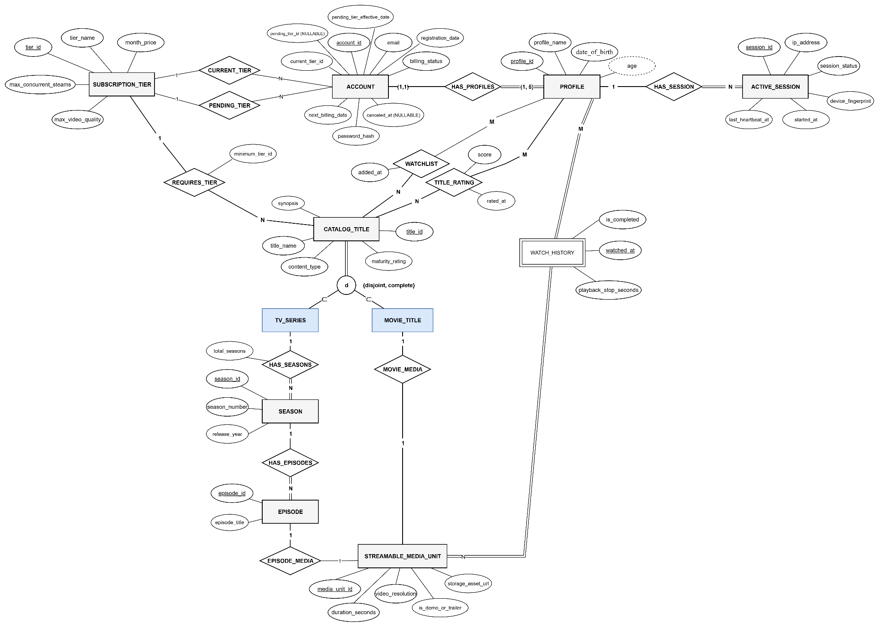
2.2 Logical Schema Mapping
2.2.1 Logical Relation Schema
1. Core Platform Entities

2. Content & Media Catalog (EER Specialization Mapping)

3. Resolved M:N Telemetry & Associative Relations

Resolved M:N Telemetry & Associative Relations
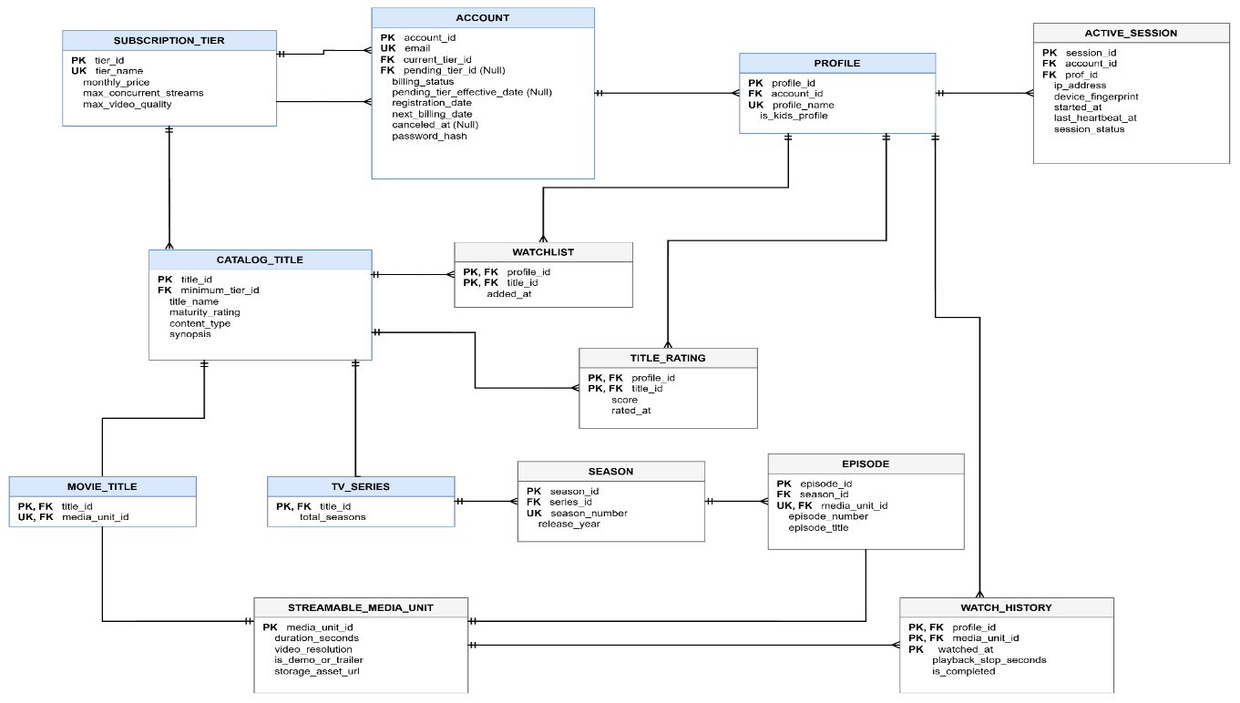
2.2.2 IE Crow's Foot Schema

2.3 Normalization Verification (Formal proofs for 1NF -> 3NF/BCNF)

2.3.1 First Normal Form (1NF) Verification
1. Core Platform Entities
- Subscription_Tier $(\underline{tier_id},tier_name,monthly_price,max_concurrent_streams,max_video_quality)$
  - Atomicity: All attributes (TINYINT, DECIMAL(6,2), VARCHAR) are scalar.
  - Evaluation: Satisfies 1NF.
- Account $(\underline{account_id},email,password_hash,billing_status,current_tier_id,pending_tier_id,pending_tier_effective_date,registration_date,next_billing_date,canceled_at)$
  - Atomicity: Dates, status enumerations, and foreign key references are scalar, primitive data types.
  - Evaluation: Satisfies 1NF.
- Profile $(\underline{profile_id},account_id,profile_name,is_kids_profile,date_of_birth)$
  - Atomicity: date_of_birth is a single scalar date rather than an unparsed composite date string. User-level settings (like language or avatar) are not crammed into comma-separated strings.
  - Evaluation: Satisfies 1NF.
2. Content & Media Catalog (EER Specialization)
- Catalog_Title $(\underline{title_id},title_name,synopsis,maturity_rating,content_type,minimum_tier_id)$
  - Atomicity: All attributes represent single values.
  - Design Note for Defense: Often in naive designs, designers store a multi-valued attribute like genres = "Action, Sci-Fi" directly in the title record, which commits a classic 1NF violation. Because your schema avoids storing repeated genre values in Catalog_Title, atomicity is preserved.
  - Evaluation: Satisfies 1NF.
- Movie_Title $(\underline{title_id},media_unit_id)$ & TV_Series $(\underline{title_id},total_seasons)$
  - Atomicity: These represent disjoint subclasses from your EER specialization (Option 8A mapping). Each stores solely its scalar attributes and foreign key.
  - Evaluation: Satisfies 1NF.
- Season $(\underline{season_id},series_id,season_number,release_year)$
  - Atomicity: Instead of embedding an array of season numbers inside TV_Series, the str

2.3.2 First Normal Form (1NF) Verification
Prime vs. non-prime attributes are evaluated with respect to all candidate keys declared in the data dictionary of §3.
A partial dependency can only exist if a key contains two or more attributes (a composite key). A single-column key cannot have a non-empty proper subset.
Because of this rule, 10 of your 13 tables are in 2NF by definition:
- Subscription_Tier ($\underline{tier_id}$)
- Account ($\underline{account_id}$)
- Profile ($\underline{profile_id}$)
- Catalog_Title ($\underline{title_id}$)
- Movie_Title ($\underline{title_id}$)
- TV_Series ($\underline{title_id}$)
- Season ($\underline{season_id}$)
- Episode ($\underline{episode_id}$)
- Streamable_Media_Unit ($\underline{media_unit_id}$)
- Active_Session ($\underline{session_id}$)
1. Watchlist
- Primary Key: {profile_id,title_id}
- Non-prime Attribute: added_at
- Dependency Analysis:
- $profile_id{↛}added_at$. (A profile bookmarks many titles at different times)
- $\left\{title_id\right\}↛added_at$. (A title is bookmarked by different profiles at different times)
- $\left\{profile_id,title_id\right\}→…$(The timestamp records the exact event of this profile saving this title)
- Verdict: added_at is fully functionally dependent on the whole primary key. Satisfies 2NF.
2. Title_Rating
- Primary Key: {profile_id,title_id}
- Non-prime Attributes: score, rated_at
- Dependency Analysis:
- $\left\{profile_id\right\}↛score$ (A user gives different scores to different movies)
- $\left\{profile_id\right\}↛score$ (A movie receives different scores from different users)
- Neither score nor rated_at can be determined by a single component of the key. Both require the combination {profile_id,title_id}.
- Verdict: Fully functionally dependent. No partial dependency exists. Satisfies 2NF.
3. Watch_History

Primary Key: {profile_id,media_unit_id,watched_at}

Non-prime Attributes: playback_stop_seconds, is_completed

Dependency Analysis:

Does a single profile or media unit alone determine the stop position? No.

Does {profile_id,media_unit_id}playback_stop_seconds? If a user watches the same media unit on multiple separate occasions (tracked by the discriminator watched_at), each viewing session has its own progress checkpoint and completion flag.

Both playback_stop_seconds and is_completed describe that specific viewing instance identified by the triplet {profile_id,media_unit_id,watched_at}.

Verdict: Fully functionally dependent. Satisfies 2NF.

2.3.3 Boyce-Codd Normal Form (BCNF)

Category A: Relations with a Single Candidate Key
When a relation has only one candidate key (which is chosen as the Primary Key) and is already in 3NF, it is guaranteed to be in BCNF. In these tables, no non-key attribute determines any other attribute:
- Profile: $profile_id→\{account_id,profile_name,is_kids_profile,date_of_birth\}$
- Catalog_Title: $title_id→\{title_name,synopsis,maturity_rating,content_type,minimum_tier_id\}$
- TV_Series: $title_id→\{total_seasons\}$
- Streamable_Media_Unit: $media_unit_id→\{duration_seconds,video_resolution,is_demo_or_trailer,storage_asset_url\}$
- Active_Session: $session_id→\{account_id,profile_id,ip_address,device_fingerprint,started_at,last_heartbeat_at,session_status\}$
- Watchlist: $\{profile_id,title_id\}→\{added_at\}$
- Title_Rating: $\{profile_id,title_id\}→\{score,rated_at\}$
- Watch_History: $\{profile_id,media_unit_id,watched_at\}→\{playback_stop_seconds,is_completed\}$
In all of the above, the left-hand side ($X$) is the Primary Key (a superkey). Therefore, each satisfies BCNF.

Category B: Relations with Multiple Candidate / Overlapping Keys
BCNF primarily exists to catch edge-case anomalies in tables with multiple overlapping candidate keys. Let’s evaluate the relations in your schema that have alternate candidate keys:
1. Subscription_Tier
- Candidate Keys: $K_{1}=\{tier_id\}$, $K_{2}=\{tier_name\}$
- Dependencies:
  - $tier_id→\{tier_name,monthly_price,max_concurrent_streams,max_video_quality\}$
  - $tier_name→\{tier_id,monthly_price,max_concurrent_streams,max_video_quality\}$
- Determinant Check: Both $tier_id$ and $tier_name$ are candidate keys (superkeys). Satisfies BCNF.
2. Account
- Candidate Keys: $K_{1}=\{account_id\}$, $K_{2}=\{email\}$
- Dependencies:
  - $account_id→\left\{email,password_hash,billing_status,…\right\}$
  - $email→\left\{account_id,password_hash,billing_status,…\right\}$
- Determinant Check: Both determinants are candidate keys (superkeys). Foreign keys like $current_tier_id$ or $pending_tier_id$ do not determine other non-key attributes within this table. Satisfies BCNF.
3. Movie_Title (1:1 Specialization Junction)
- Candidate Keys: $K_{1}=\{title_id\}$, $K_{2}=\{media_unit_id\}$
- Dependencies:
  - $title_id→media_unit_id$
  - $media_unit_id→title_id$
- Determinant Check: Both are superkeys. Satisfies BCNF.
4. Season
- Candidate Keys: $K_{1}=\{season_id\}$, $K_{2}=\{series_id,season_number\}$
- Dependencies:
  - $season_id→\{series_id,season_number,release_year\}$
  - $\{series_id,season_number\}→\{season_id,release_year\}$
- Determinant Check: Neither $series_id$ nor $season_number$ alone determines $release_year$. The only determinants are the two candidate keys. Both are superkeys. Satisfies BCNF.
5. Episode
- Candidate Keys:
  - $K_{1}=\{episode_id\}$
  - $K_{2}=\{media_unit_id\}$ (each episode has exactly one unique playable stream)
  - $K_{3}=\{season_id,episode_number\}$
- Dependencies: Every non-trivial dependency has $K_{1}$, $K_{2}$, or $K_{3}$ as its determinant. Since each determinant is a candidate key, it satisfies BCNF.

3. Data Dictionary (Adapted from ISO/IEC 11179)
3.1 Core Platform & Membership Entities
Table 3.1.1: Subscription_Tier
Defines service tier definitions, pricing, concurrent stream caps, and maximum streaming resolution.
Attribute Name | Data Type | Key Type | Nullable? | Default Value | Business Rules / Constraints
tier_id | TINYINT UNSIGNED | PK | No | None | Surrogate primary key. Domain constraint: $∈\{0,1,2,3\}$ ($0=Free/Guest$, $1=Basic$, $2=Standard$, $3=Premium$).
tier_name | VARCHAR(20) | AK | No | None | Unique tier name (UNIQUE). Restricted to: 'Free', 'Basic', 'Standard', 'Premium'.
monthly_price | DECIMAL(6,2) | None | No | 0.00 | Monthly recurring subscription charge in USD. Must satisfy $≥0.00$. Fixed at 0.00 for tier_id = 0.
max_concurrent_streams | TINYINT UNSIGNED | None | No | 1 | Max active streaming sessions allowed concurrently across the account ($1≤n≤10$).
max_video_quality | VARCHAR(10) | None | No | '480p' | Maximum stream resolution permitted: '480p', '720p', '1080p', '4K UHD'.
Table 3.1.2: Account
Master billing account entity responsible for subscription ownership and administrative privileges.
Attribute Name | Data Type | Key Type | Nullable? | Default Value | Business Rules / Constraints
account_id | INT UNSIGNED | PK | No | None | Auto-incrementing surrogate primary key identifying the customer account.
email | VARCHAR(255) | AK | No | None | Unique login credential (UNIQUE). Must satisfy standard RFC 5322 email regex pattern.
password_hash | CHAR(60) | None | No | None | Cryptographic password digest generated via bcrypt/Argon2. Fixed length of 60 characters.
billing_status | VARCHAR(20) | None | No | 'Active' | Domain constraint: CHECK (billing_status IN ('Active', 'Past_Due', 'Suspended', 'Inactive')).
current_tier_id | TINYINT UNSIGNED | FK | No | 1 | References Subscription_Tier(tier_id) ON DELETE RESTRICT ON UPDATE CASCADE.
pending_tier_id | TINYINT UNSIGNED | FK | Yes | NULL | References Subscription_Tier(tier_id) ON DELETE SET NULL ON UPDATE CASCADE. Stores scheduled downgrade tier (BR-14).
pending_tier_effective_date | DATE | None | Yes | NULL | Effective start date of pending subscription change. Must satisfy $≥registration_date$.
registration_date | DATE | None | No | (CURRENT_DATE) | Calendar date when the account was initially created.
next_billing_date | DATE | None | No | None | Date of upcoming 30-day recurring charge (BR-12). Must satisfy $>registration_date$.
canceled_at | TIMESTAMP | None | Yes | NULL | Timestamp of subscription cancellation. Triggers the 10-month data retention grace period (BR-15).

Table 3.1.3: Profile
Viewer partition entity isolated under a parent Account. Enforces viewing boundaries and parental controls.
Attribute Name | Data Type | Key Type | Nullable? | Default Value | Business Rules / Constraints
profile_id | INT UNSIGNED | PK | No | None | Auto-incrementing unique identifier for each viewer partition.
account_id | INT UNSIGNED | FK | No | None | References Account(account_id) ON DELETE CASCADE ON UPDATE CASCADE (BR-06).
profile_name | VARCHAR(30) | None | No | None | Display moniker. Composite Candidate Key: UNIQUE(account_id, profile_name).
is_kids_profile | BOOLEAN | None | No | FALSE | Parental control flag. If TRUE, access is restricted from 'R' and 'TV-MA' content (BR-04).
date_of_birth | DATE | None | Yes | NULL | Viewer birth date. Used to compute dynamic derived age: $(CURRENT_DATE-date_of_birth)$.

3.2 Content Catalog, EER Hierarchy & Media Units

Table 3.2.1: Catalog_Title (EER Superclass)
High-level abstract media catalog container for all browsable, discoverable entertainment assets.
Attribute Name | Data Type | Key Type | Nullable? | Default Value | Business Rules / Constraints
title_id | INT UNSIGNED | PK | No | None | Unique surrogate primary key identifying each catalog entry.
title_name | VARCHAR(150) | None | No | None | Official public display name of the title. Cannot be blank or empty string.
synopsis | TEXT | None | Yes | NULL | Descriptive narrative summary and storyline overview.
maturity_rating | VARCHAR(10) | None | No | 'PG' | Domain constraint: CHECK (maturity_rating IN ('G', 'PG', 'PG-13', 'R', 'NC-17', 'TV-Y', 'TV-G', 'TV-PG', 'TV-14', 'TV-MA')).
content_type | VARCHAR(10) | None | No | None | EER Specialization Discriminator: CHECK (content_type IN ('Movie', 'Series')).
minimum_tier_id | TINYINT UNSIGNED | FK | No | 0 | References Subscription_Tier(tier_id) ON DELETE RESTRICT ON UPDATE CASCADE (BR-01, BR-09).

Table 3.2.2: Movie_Title (EER Subclass)
Specialized feature film subclass inheriting base title metadata and linking to a single media file.
Attribute Name | Data Type | Key Type | Nullable? | Default Value | Business Rules / Constraints
title_id | INT UNSIGNED | PK, FK | No | None | References Catalog_Title(title_id) ON DELETE CASCADE ON UPDATE CASCADE (Option 8A mapping).
media_unit_id | INT UNSIGNED | FK, AK | No | None | References Streamable_Media_Unit(media_unit_id) ON DELETE RESTRICT ON UPDATE CASCADE. Unique constraint UNIQUE(media_unit_id) enforces a strict 1:1 media binding.

Table 3.2.3: TV_Series (EER Subclass)
Specialized episodic television program subclass inheriting base catalog metadata.
Attribute Name | Data Type | Key Type | Nullable? | Default Value | Business Rules / Constraints
title_id | INT UNSIGNED | PK, FK | No | None | References Catalog_Title(title_id) ON DELETE CASCADE ON UPDATE CASCADE (Option 8A mapping).
total_seasons | SMALLINT UNSIGNED | None | No | 1 | Aggregate count of produced seasons. Must satisfy CHECK (total_seasons >= 1).

Table 3.2.4: Season
Intermediate structural grouping container for serialized TV series programs.
Attribute Name | Data Type | Key Type | Nullable? | Default Value | Business Rules / Constraints
season_id | INT UNSIGNED | PK | No | None | Unique surrogate primary key identifying each specific season block.
series_id | INT UNSIGNED | FK | No | None | References TV_Series(title_id) ON DELETE CASCADE ON UPDATE CASCADE.
season_number | SMALLINT UNSIGNED | None | No | 1 | Relative season counter. Composite Candidate Key: UNIQUE(series_id, season_number) prevents duplicate season numbering.
release_year | SMALLINT UNSIGNED | None | No | None | Original broadcast calendar year. Domain constraint: CHECK (release_year BETWEEN 1900 AND 2100).

Table 3.2.5: Episode
Concrete episodic unit belonging to a specific season, linked to a streamable video asset.
Attribute Name | Data Type | Key Type | Nullable? | Default Value | Business Rules / Constraints
episode_id | INT UNSIGNED | PK | No | None | Auto-incrementing primary key identifying each broadcast episode.
season_id | INT UNSIGNED | FK | No | None | References Season(season_id) ON DELETE CASCADE ON UPDATE CASCADE.
media_unit_id | INT UNSIGNED | FK, AK | No | None | References Streamable_Media_Unit(media_unit_id) ON DELETE RESTRICT ON UPDATE CASCADE. Unique constraint UNIQUE(media_unit_id) enforces a strict 1:1 media binding.
episode_number | SMALLINT UNSIGNED | None | No | 1 | Episode sequence within season. Composite Candidate Key: UNIQUE(season_id, episode_number).
episode_title | VARCHAR(150) | None | No | None | Public broadcast name/title of the specific episode.

Table 3.2.6: Streamable_Media_Unit
Physical media file asset metadata delivering encoded digital video chunks to client players.
Attribute Name | Data Type | Key Type | Nullable? | Default Value | Business Rules / Constraints
media_unit_id | INT UNSIGNED | PK | No | None | Unique surrogate primary key identifying the streamable media container.
duration_seconds | INT UNSIGNED | None | No | None | Total playback run-time in seconds. Must satisfy CHECK (duration_seconds > 0).
video_resolution | VARCHAR(10) | None | No | '480p' | Native encoded resolution. Domain constraint: CHECK (video_resolution IN ('480p', '720p', '1080p', '4K UHD')).
is_demo_or_trailer | BOOLEAN | None | No | FALSE | Promotional flag. If TRUE, accessible by inactive/guest tiers without billing validation (BR-09).
storage_asset_url | VARCHAR(500) | None | No | None | CDN endpoint or Cloud Object Storage URI pointing to HLS/DASH manifest files (.m3u8 / .mpd).

3.3 User Activity, Telemetry & Session Entities (Resolved M:N)

Table 3.3.1: Watchlist
Associative entity resolving the $M:N$ relationship between Profile and Catalog_Title.
Attribute Name | Data Type | Key Type | Nullable? | Default Value | Business Rules / Constraints
profile_id | INT UNSIGNED | PK, FK | No | None | References Profile(profile_id) ON DELETE CASCADE ON UPDATE CASCADE (BR-03, BR-06).
title_id | INT UNSIGNED | PK, FK | No | None | References Catalog_Title(title_id) ON DELETE CASCADE ON UPDATE CASCADE.
added_at | TIMESTAMP | None | No | CURRENT_TIMESTAMP | System timestamp recorded when the user bookmarked the title.

Table 3.3.2: Title_Rating
Associative entity resolving the $M:N$ relationship for explicit user ratings and scores.
Attribute Name | Data Type | Key Type | Nullable? | Default Value | Business Rules / Constraints
profile_id | INT UNSIGNED | PK, FK | No | None | References Profile(profile_id) ON DELETE CASCADE ON UPDATE CASCADE (BR-03, BR-06).
title_id | INT UNSIGNED | PK, FK | No | None | References Catalog_Title(title_id) ON DELETE CASCADE ON UPDATE CASCADE.
score | TINYINT UNSIGNED | None | No | None | Quantitative rating score. Domain constraint: CHECK (score BETWEEN 1 AND 10).
rated_at | TIMESTAMP | None | No | CURRENT_TIMESTAMP | Timestamp of rating creation or last update.

Table 3.3.3: Watch_History
High-velocity telemetry event log storing playback checkpoints and completion metrics.
Attribute Name | Data Type | Key Type | Nullable? | Default Value | Business Rules / Constraints
profile_id | INT UNSIGNED | PK, FK | No | None | References Profile(profile_id) ON DELETE CASCADE ON UPDATE CASCADE (BR-03, BR-06).
media_unit_id | INT UNSIGNED | PK, FK | No | None | References Streamable_Media_Unit(media_unit_id) ON DELETE CASCADE ON UPDATE CASCADE.
watched_at | TIMESTAMP | PK | No | CURRENT_TIMESTAMP | Timestamp of playback event. Forms composite PK (profile_id, media_unit_id, watched_at).
playback_stop_seconds | INT UNSIGNED | None | No | 0 | Resumable playhead offset in seconds. Must satisfy $≥0$.
is_completed | BOOLEAN | None | No | FALSE | Completion status flag. Set to TRUE if playhead reaches  of total media duration.

Table 3.3.4: Active_Session
Real-time active stream tracking table enforcing subscription concurrent device limits.
Attribute Name | Data Type | Key Type | Nullable? | Default Value | Business Rules / Constraints
session_id | CHAR(36) | PK | No | None | Globally unique identifier (UUID v4) generated per active streaming client session.
account_id | INT UNSIGNED | FK | No | None | References Account(account_id) ON DELETE CASCADE ON UPDATE CASCADE (used for BR-02 stream limit aggregation).
profile_id | INT UNSIGNED | FK | No | None | References Profile(profile_id) ON DELETE CASCADE ON UPDATE CASCADE. Composite FK (account_id, profile_id) references Profile(account_id, profile_id).
ip_address | VARCHAR(45) | None | No | None | Client public egress IP address (supports standard IPv4 and IPv6 notations).
device_fingerprint | VARCHAR(100) | None | No | None | Client device/browser hardware hash identifier.
started_at | TIMESTAMP | None | No | CURRENT_TIMESTAMP | Session connection establishment timestamp.
last_heartbeat_at | TIMESTAMP | None | No | CURRENT_TIMESTAMP | Real-time keep-alive ping timestamp. Stale records ($>60s$) are purged to free concurrent slots.
session_status | VARCHAR(15) | None | No | 'Active' | Domain constraint: CHECK (session_status IN ('Active', 'Paused', 'Terminated')).

4. Database Implementation (SQL Style Guide Compliant)
4.1 DDL Script (Tables, Views, Indexes, Triggers)
4.2 Advanced Queries & Performance Test Cases
5. Verification & Security
5.1 Test cases showing constraints prevent bad data insertion
5.2 Role-Based Access Control (RBAC) definition (GRANT/REVOKE statements)

